Illinois Mathematics and Science Academy
Department of English
Sophomore Summer Reading, 2018

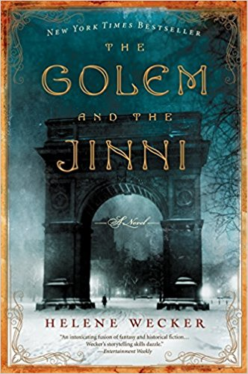
The Golem and the Jinni, by Helene Wecker
ISBN-10: 0062110845
ISBN-13: 978-0062110848

Publisher’s description of The Golem and the Jinni, excerpted from Amazon.com:

﻿“In The Golem and the Jinni, a chance meeting between mythical beings takes readers on a dazzling journey through cultures in turn-of-the-century New York.
Chava is a golem, a creature made of clay, brought to life by a disgraced rabbi who dabbles in dark Kabbalistic magic and dies at sea on the voyage from Poland. Chava is unmoored and adrift as the ship arrives in New York harbor in 1899.
Ahmad is a jinni, a being of fire born in the ancient Syrian desert, trapped in an old copper flask, and released in New York City, though still not entirely free
Ahmad and Chava become unlikely friends and soul mates with a mystical connection. Marvelous and compulsively readable, Helene Wecker's debut novel The Golem and the Jinni weaves strands of Yiddish and Middle Eastern literature, historical fiction and magical fable, into a wondrously inventive and unforgettable tale.”

Why has the English Team chosen this text for summer reading?
Many of the texts in Literary Explorations I address culture, identity, and immigration, topics deeply embedded in Wecker’s historical fantasy. America’s current political climate has placed racial and ethnic origin at the center of our national consciousness, igniting debates about America’s identity, our legal system, and our relationship to the world beyond our borders. By weaving mythological creatures and magic into a diverse urban landscape, Wecker offers a new perspective on these issues as well as insight into their historical contexts.

Annotation and Careful Reading
Your teachers encourage the practice of careful annotation in all of your assigned reading at IMSA. Keep track of your impressions of the texts, the questions they raise for you, the language you find striking or difficult, and so forth. Doing so will help reinforce active reading habits and prepare you to be a strong participant in the first weeks of Literary Explorations I.

What can you expect in your English class at the beginning of the school year?
Students will be asked to discuss, debate, and identify important details and ideas drawn from the text, which will serve as springboards for in-class activities and assessments and out-of-class assignments. Students should plan to keep their copy the text on campus throughout the fall, as their teacher may reference it throughout the course.

Guiding Questions
In addition to developing questions of your own, we encourage you to consider the following questions as you read:

1. Chava (pronounced “Hah-vah”) is created to be a servant, but happenstance grants her freedom she doesn’t fully understand or know how to use. Where is she least successful in adapting to the world around her? Where is she at her best? What might this tell us about her character?

2. In many ways, Ahmad is a foil to Chava: arrogant, demanding, impatient, and imperious. Find some moments in the text that best portray his personality, and some moments that do the same for Chava, and consider them in contrast to one another.

3. Wecker might have chosen to write The Golem and the Jinni as historical fiction, casting Ahmad and Chava as a Syrian man and a Jewish woman, both human beings. How does fantasy provide Wecker valuable tools for exploring immigration and personal identity – ones that might not be available in “realistic fiction”?

4. Magic makes Chava and Ahmad very powerful. It also makes them vulnerable and dangerous to others. Explore their relationship to their powers, and what Wecker might be indicating about magic as a means of solving problems.

